2015 Penn State sexual misconduct climate survey

summary Report: BEHREND

This report highlights the major findings for Behrend from the Sexual Misconduct Climate Survey conducted University-wide in fall 2015.

Introduction 1

Methodology 1

Survey Instrument 1

Sampling and Distribution 1

Response Rates and Characteristics 2

Results 3

Perceptions of Campus Climate 3

Student Perceptions of How the University Would Handle a Report of Sexual Misconduct 3

Student Perceptions of Peer Attitudes 4

Overall Feeling of Safety 5

Knowledge of Resources 6

Offensive Behaviors and Potential Harassment 7

Overall Offensive Behavior/Harassment 8

Offensive Behavior/Harassment by Faculty/Staff 8

Offensive Behavior/Harassment by Other Students 9

Stalking Behaviors 11

Intimate Partner and Dating Violence 12

Non-consensual Sexual Contact and Sexual Assault Victimization 14

Victimization Rates of Any Non-consensual Sexual Contact 15

Victimization Rates of Sexual Assault 15

Victimization Rates of Non-consensual Sexual Touching, Fondling, or Kissing 17

Context of Any Non-consensual Sexual Contact Victimization 18

Reporting 19

Bystander Intervention Behavior 20

Comparisons to National Data 21

Perceptions of Campus Climate 22

Offensive Behaviors and Potential Harassment 22

Stalking 22

Intimate Partner and Dating Violence 23

Non-consensual Sexual Contact 23

# Introduction

The 2015 Penn State Sexual Misconduct Climate Survey was created with the primary goal of gathering data regarding student perceptions of sexual misconduct, prevalence rates of such misconduct, University response, and knowledge of resources available in regard to sexual misconduct at the University. The data are meant to inform policy, programming, and educational efforts across the University aimed at reducing sexual misconduct and improving the experience of all Penn State students. The survey also fulfills one of the recommendations set forth in the University’s 2015 Sexual Assault and Sexual Harassment Task Force report, which can be found at the following link: http://www.psu.edu/ur/2014/Task_Force_final_report.pdf.

This report focuses on the Behrend campus, and, when possible, provides comparative numbers from national data to help situate the survey’s data within the broader national context of sexual misconduct on college and university campuses.

# Methodology

## Survey Instrument

The survey used was a modified version of the Administrator Researcher Campus Climate Collaborative (ARC3) survey. This effort brought together academics who focus their research on topics of sexual assault and sexual misconduct as well as administrators from institutions across the country. More information on ARC3 and the process of creating the survey can be found at: http://campusclimate.gsu.edu/.

The University chose to utilize a modified ARC3 instrument after considering alternative models. One such alternative was an instrument developed by the Association of American Universities (AAU). However, the University noted various concerns regarding the methodology used in developing and administering the AAU survey. For example, at that time, the AAU was requiring institutions to commit to using the survey without institutions having the opportunity to see the instrument that would be used. Given this lack of transparency in the early stages of the AAU survey administration, there were many concerns expressed both internally and externally to Penn State regarding signing on with the AAU process. A number of letters were drafted and sent to university presidents across the country from researchers of sexual assault and others vested in the issue. Given these concerns, it was decided that Penn State was more likely to benefit from conducting its own survey based on an instrument that was created using a transparent process with input from leaders in the field of sexual assault research from across the country.

Once the decision was made to use the ARC3 survey, the initial ARC3 instrument was sent to a pilot sample of students in spring 2015 in order to solicit feedback from the student perspective. Responses from this pilot administration informed discussions resulting in some modifications such as minor wording changes and additions and subtractions of content within the survey.

## Sampling and Distribution

Penn State contracted with DatStat, Inc. to distribute the survey and host the data. This enabled a distribution that ensured anonymity of responses but allowed for tracking of individuals who completed the survey for the purpose of reminder emails and incentive drawings. DatStat also provided the technical support and reporting tools essential for this project.

At Behrend, a random sample of 1,500 undergraduate students was selected to receive the survey via email. All undergraduate students were 18 years of age or older, degree-seeking, and enrolled in at least 6 credits in fall 2015.[1]

During the week prior to the survey launch, students selected to receive the survey were sent an email from Vice President for Student Affairs, Damon Sims, to inform them of their selection and to encourage them to take the time to complete the survey. The survey was then open for three weeks with two reminder emails sent each week to non-respondents. Those who completed the survey were entered into a random drawing for the incentive items, which included: 8 iPad Airs, 40 $50 VISA gift cards, 8 mini speakers, 40 $10 Starbucks gift cards, and 8 sets of earbuds. (Note: these were the total incentives that were given out University-wide).

## Response Rates and Characteristics

Overall, 30.0% (N = 450) of undergraduate students completed the survey. Responses were considered complete if at least 90% of the survey questions were answered. The confidence interval was +/-0.95% for the University-wide administration and +/-4.36% at Behrend. Table 1 illustrates some of the demographic characteristics of respondents.

**Table 1. Selected demographics in percentages.**

|  | |  |
| --- | --- | --- |
| Gender | Female | 40.4 |
| Male | 59.6 |
| Race/International Status | Domestic White | 80.1 |
| Domestic Non-White | 13.9 |
| International | 6.0 |
| Living Situation | On campus | 50.2 |
|  | Off Campus | 49.8 |

Note: Percentages do not add to 100 when some students selected “other” or “prefer not to answer.”

# Results

The following sections summarize some of the most important pieces of data from the survey administration, as well as pieces of data that are commonly points of focus for studies regarding sexual misconduct at colleges and universities. Data points are split by gender in addition to overall figures. (Note: LGBTQ data are not reported for campuses other than University Park because there were not sufficient responses from LGBTQ students at other campuses.)

At the end of this report, a number of comparisons are made to national statistics. Specifically, when possible, comparisons are made to the Association of American Universities (AAU) climate survey that was conducted in 2015 as mentioned above. Despite the numerous initial concerns regarding signing on to conduct the AAU survey, it is the best recently released comparative data. Differences in survey methodology and question semantics will be noted when appropriate. In addition, it is important to note that the AAU survey was conducted in spring 2015 as opposed to fall 2015. The AAU survey consisted of 27 institutions that varied widely on a multitude of institutional characteristics. While comparisons to the average rates and responses from this survey are sometimes convenient, doing so simplifies the fact that many of the key points from the AAU survey have large ranges that are not necessarily best summarized with a single number. In fact, the AAU report stresses that making broad generalizations from survey results — such as “1 in 4” or “1 in 5 college women students” have been sexually assaulted while in college — oversimplifies both the survey data and the complexity of the problem of sexual violence on college campuses. Despite these caveats, comparisons to the average can be helpful in determining areas in which more immediate focus may be beneficial.

## Perceptions of Campus Climate

Students were asked to report their perceptions regarding the campus climate in relation to sexual misconduct, including their perception of how the University would handle a report of sexual misconduct, their assessment of peers’ attitudes regarding various norms related to sex-seeking behaviors, and their overall feeling of safety from various forms of sexual misconduct on or around campus. These results are highlighted below.

### Student Perceptions of How the University Would Handle a Report of Sexual Misconduct

Students were asked questions about how the University would respond to instances of sexual misconduct. These data are shown in Table 2.

**Table 2. Percentages of students reporting the following institutional responses were “likely” or “very likely” to occur if a student reported an incident of sexual misconduct at Penn State.**

|  |  |  |  |
| --- | --- | --- | --- |
|  |  | | |
|  | Women | Men | Overall |
| The institution would take the report seriously. | 83.2 | 86.7 | 85.1 |
| The institution would maintain the privacy of the person making the report. | 90.5 | 88.2 | 89.1 |
| The institution would do its best to honor the request of the person about to go forward with the case. | 79.3 | 81.4 | 80.7 |
| The institution would take steps to protect the safety of the person making the report. | 82.1 | 88.6 | 86.2 |
| The institution would provide accommodations to support the person (e.g. academic, housing, safety). | 73.2 | 76.0 | 74.6 |
| The institution would take action to address factors that may have led to the sexual misconduct. | 79.3 | 82.9 | 81.1 |
| The institution would handle the report fairly. | 78.8 | 79.3 | 79.0 |

### Student Perceptions of Peer Attitudes

Respondents were asked a series of questions about the attitudes their peers hold about expectations and appropriate behaviors surrounding sex and relationships. These results are summarized in Table 3. These results indicate that students mostly did not agree that their peers hold the attitudes asked about in this section.

**Table 3. Percentages of students who “agree” or “strongly agree” that their friends would approve of behaviors listed.**

|  |  |  |  |
| --- | --- | --- | --- |
|  |  | | |
|  | Women | Men | Overall |
| Getting someone drunk or high to have sex with them. | 1.1 | 3.9 | 2.7 |
| Lying to someone in order to have sex with them. | 0.5 | 5.0 | 3.1 |
| Forcing someone to have sex. | 0.0 | 0.0 | 0.0 |
| Using physical force, such as hitting or beating, to resolve conflicts with dates. | 0.0 | 0.0 | 0.0 |
| Insulting or swearing at dates. | 0.5 | 1.4 | 1.0 |
| It is alright for someone to hit a date in certain situations. | 1.1 | 1.4 | 1.3 |
| Someone you are dating should have sex with you when you want. | 6.8 | 1.8 | 3.8 |
| When you spend money on a date, the person should have sex with you in return. | 0.0 | 0.7 | 0.4 |
| You should respond to a date’s challenges to your own authority by insulting them or putting them down. | 0.0 | 0.0 | 0.0 |
| It is alright to physically force a person to have sex under certain conditions. | 0.0 | 0.4 | 0.2 |

### Overall Feeling of Safety

Students rated how safe they felt on campus from various forms of sexual misconduct, specifically harassment, dating violence, sexual violence, and stalking. Responses are summarized in Table 4.

**Table 4. Percentages of students who “agree” or “strongly agree” that they feel safe from various forms of sexual misconduct.**

|  |  |  |  |
| --- | --- | --- | --- |
|  |  | | |
|  | Women | Men | Overall |
| On or around this campus, I feel safe from sexual harassment. | 73.7 | 87.9 | 81.8 |
| On or around this campus, I feel safe from dating violence. | 82.6 | 88.9 | 86.0 |
| On or around this campus, I feel safe from sexual violence. | 78.9 | 89.3 | 84.7 |
| On or around this campus, I feel safe from stalking. | 74.1 | 81.4 | 78.2 |

Students were then asked three questions about their own attitudes regarding sexual misconduct on campus, including whether they think: sexual misconduct is a problem on campus, they can do anything about sexual misconduct on campus, and they should think about the issue of sexual misconduct while in college. These results are summarized in Table 5.

**Table 5. Percentages of students who “agree” or “strongly agree” with items regarding sexual misconduct being a problem at Penn State.**

|  |  |  |  |
| --- | --- | --- | --- |
|  |  | | |
|  | Women | Men | Overall |
| I don’t think sexual misconduct is a problem at Behrend. | 37.9 | 54.8 | 47.2 |
| I don’t think there is much I can do about sexual misconduct on this campus. | 11.1 | 23.7 | 18.4 |
| There isn’t much need for me to think about sexual misconduct while at college. | 12.1 | 28.8 | 21.6 |

## Knowledge of Resources

Students were asked a number of questions about their awareness regarding various resources and information available in connection with issues of sexual misconduct, including whether they recall receiving written information regarding various University policies and procedures, and whether they are aware of various University offices and websites related to sexual misconduct. Table 6 summarizes what information students recall receiving from the University since arriving at Behrend.

**Table 6. Percentages of students indicating they had received written information regarding sexual misconduct policies, definitions, and resources.**

|  |  |  |  |
| --- | --- | --- | --- |
|  |  | | |
|  | Women | Men | Overall |
| Definitions of types of sexual misconduct | 45.8 | 41.1 | 43.3 |
| How to report an incident of sexual misconduct | 46.3 | 34.4 | 39.8 |
| Where to go to get help if someone you know experiences sexual misconduct | 49.0 | 34.8 | 40.8 |
| Title IX protections against sexual misconduct | 19.0 | 19.9 | 19.8 |
| How to help prevent sexual misconduct | 49.0 | 45.4 | 46.9 |
| Student code of conduct or honor code | 49.5 | 57.5 | 54.8 |

Respondents were also asked to rate their level of awareness regarding three offices/resources available to students at Behrend in connection with issues of sexual misconduct. Table 7 summarizes the percentage of students reporting that they were either “very aware” or “extremely aware” of the resource in question.

**Table 7. Percentages of students responding “very aware” or “extremely aware” of resource.**

|  |  |  |  |
| --- | --- | --- | --- |
|  |  | | |
|  | Women | Men | Overall |
| Office of Student Conduct | 17.4 | 16.0 | 17.1 |
| Title IX Compliance | 7.4 | 9.3 | 8.8 |
| SHARE Website[2] | 11.1 | 7.1 | 9.0 |

## Offensive Behaviors and Potential Harassment

The survey included a number of questions regarding offensive behaviors that could potentially constitute harassment. Given the limitations of questionnaires in gathering rich, nuanced data, the items in this section do not fit a legal definition of harassment nor do they fit the student conduct policy definition of harassment. Students were asked in separate sections of the survey if any students or faculty/staff members exhibited any of the following behaviors:

* Treated you “differently” because of your sex.
* Displayed, used, or distributed sexist or suggestive materials.
* Made offensive sexist remarks (including cat-calls).
* Put you down or was condescending to you because of your sex.
* Repeatedly told sexual stories or jokes that were offensive to you.
* Made unwelcome attempts to draw you into a discussion of sexual matters.
* Made offensive remarks about your appearance, body, or sexual activities.
* Made gestures or used body language of a sexual nature which embarrassed or offended you.
* Sent or posted unwelcome sexual comments, jokes, or pictures by text, email, Facebook, or other electronic means.
* Spread unwelcome rumors about you by text, email, Facebook, or other electronic means.
* Called you gay or lesbian in a negative way by text, email, Facebook, or other electronic means.
* Made unwanted attempts to establish a romantic sexual relationship with you despite your efforts to discourage it.
* Continued to ask you for dates, drinks, dinner, etc., even though you said “no”.
* Touched you in a way that made you feel uncomfortable.
* Made unwanted attempts to stroke, fondle, or kiss you.
* Made you feel like you were being bribed with a reward to engage in sexual behavior.
* Made you feel threatened with some sort of retaliation for not being sexually cooperative.
* Treated you badly for refusing to have sex.
* Implied better treatment if you were sexually cooperative.

### Overall Offensive Behavior/Harassment

When all of these offensive and potentially harassing behaviors are combined and the person(s) committing the behaviors is not taken into account, 48.7% of Behrend students overall, 59.2% of women and 41.1% of men report experiencing at least one offensive or potentially harassing behavior. More information can be gleaned from these data as who committed the behaviors and which specific behaviors were most commonly experienced are investigated.

### Offensive Behavior/Harassment by Faculty/Staff

Students were asked about offensive or harassing behaviors that were committed by faculty or staff. Behrend students reported an overall rate of 26.2%, with 30.7% of women and 22.8% of men reporting that at least one of the 19 offensive or harassing behaviors were committed by faculty or staff. Tables 8a and 8b break down responses regarding offensive behaviors committed by faculty/staff based on the specific behaviors delineated in the survey. Table 8a looks at all items that involve being treated differently based on sex or verbally offensive remarks and Table 8b looks at items that involve trying to engage the student in an unwanted romantic or sexual relationship.

**Table 8a. Percentages of students reporting specific offensive behaviors by faculty/staff.**

|  |  |  |  |
| --- | --- | --- | --- |
|  |  | | |
|  | Women | Men | Overall |
| Treated you “differently” because of your sex | 23.7 | 14.3 | 18.4 |
| Displayed, used, or distributed sexist or suggestive materials | 11.6 | 10.0 | 10.6 |
| Made offensive sexist remarks (including cat-calls) | 13.7 | 11.4 | 12.5 |
| Put you down or was condescending to you because of your sex | 12.1 | 5.4 | 8.4 |
| Repeatedly told sexual stories or jokes that were offensive to you | 11.1 | 5.0 | 7.5 |
| Made unwelcome attempts to draw you into a discussion of sexual matters | 1.6 | 1.8 | 1.7 |
| Made offensive remarks about your appearance, body, or sexual activities | 2.6 | 1.4 | 2.1 |
| Made gestures or used body language of a sexual nature which embarrassed or offended you | 2.6 | 1.4 | 2.1 |
| Sent or posted unwelcome sexual comments, jokes or pictures by text, email, Facebook, or other electronic means | 1.1 | 0.7 | 0.8 |
| Spread unwelcome sexual rumors about you by text, email, Facebook, or other electronic means | 1.1 | 0.4 | 0.6 |
| Called you gay or lesbian in a negative way by text, email, Facebook, or other electronic means | 1.1 | 0.4 | 0.8 |

**Table 8b. Percentages of students reporting specific behaviors to attempt to engage in unwanted romantic or sexual relationships by faculty/staff.**

|  |  |  |  |
| --- | --- | --- | --- |
|  |  | | |
|  | Women | Men | Overall |
| Made unwanted attempts to establish a romantic sexual relationship with you despite your efforts to discourage it | 1.6 | 0.7 | 1.0 |
| Continued to ask you for dates, drinks, dinner, etc., even though you said “No” | 1.6 | 1.1 | 1.3 |
| Touched you in a way that made you feel uncomfortable | 2.1 | 0.7 | 1.3 |
| Made unwanted attempts to stroke, fondle, or kiss you | 0.5 | 0.7 | 0.6 |
| Made you feel like you were being bribed with a reward to engage in sexual behavior | 0.5 | 0.7 | 0.6 |
| Made you feel threatened with some sort of retaliation for not being sexually cooperative | 0.0 | 0.7 | 0.4 |
| Treated you badly for refusing to have sex | 0.5 | 0.3 | 0.4 |
| Implied better treatment if you were sexually cooperative | 0.5 | 0.4 | 0.4 |

### Offensive Behavior/Harassment by Other Students

Students were also asked about offensive or harassing behaviors that were committed by other students. Behrend students reported an overall rate of 40.7%, with 55.3% of women and 30.0% of men reporting that at least one of the 19 offensive or harassing behaviors were committed by another student or students. Tables 9a and 9b break down responses of student offensive behaviors and harassment based on the specific behaviors delineated in the survey. Table 9a, looks at all items that involve being treated differently based on sex or verbally offensive remarks. Table 9b looks at items that involve trying to engage the student in an unwanted romantic or sexual relationship.

**Table 9a. Percentages of students reporting specific offensive behaviors by students.**

|  |  |  |  |
| --- | --- | --- | --- |
|  |  | | |
|  | Women | Men | Overall |
| Treated you “differently” because of your sex | 32.1 | 13.5 | 21.5 |
| Displayed, used, or distributed sexist or suggestive materials | 22.6 | 11.7 | 16.5 |
| Made offensive sexist remarks (including cat-calls) | 35.8 | 11.0 | 21.5 |
| Put you down or was condescending to you because of your sex | 24.9 | 9.6 | 16.3 |
| Repeatedly told sexual stories or jokes that were offensive to you | 23.8 | 7.1 | 14.4 |
| Made unwelcome attempts to draw you into a discussion of sexual matters | 19.0 | 8.9 | 13.2 |
| Made offensive remarks about your appearance, body, or sexual activities | 23.3 | 10.3 | 15.9 |
| Made gestures or used body language of a sexual nature which embarrassed or offended you | 16.8 | 6.1 | 10.5 |
| Sent or posted unwelcome sexual comments, jokes or pictures by text, email, Facebook, or other electronic means | 7.4 | 2.8 | 5.0 |
| Spread unwelcome sexual rumors about you by text, email, Facebook, or other electronic means | 3.2 | 3.2 | 3.1 |
| Called you gay or lesbian in a negative way by text, email, Facebook, or other electronic means | 3.2 | 2.5 | 3.1 |

**Table 9b. Percentages of students reporting specific behaviors to attempt to engage in unwanted romantic or sexual relationships by students.**

|  |  |  |  |
| --- | --- | --- | --- |
|  |  | | |
|  | Women | Men | Overall |
| Made unwanted attempts to establish a romantic sexual relationship with you despite your efforts to discourage it | 23.2 | 7.8 | 14.4 |
| Continued to ask you for dates, drinks, dinner, etc., even though you said “No” | 24.7 | 5.3 | 13.6 |
| Touched you in a way that made you feel uncomfortable | 22.1 | 6.4 | 12.9 |
| Made unwanted attempts to stroke, fondle, or kiss you | 17.4 | 8.2 | 12.3 |
| Made you feel like you were being bribed with a reward to engage in sexual behavior | 6.8 | 3.2 | 4.8 |
| Made you feel threatened with some sort of retaliation for not being sexually cooperative | 5.3 | 1.4 | 2.9 |
| Treated you badly for refusing to have sex | 10.0 | 3.2 | 6.3 |
| Implied better treatment if you were sexually cooperative | 6.8 | 2.8 | 4.4 |

## Stalking Behaviors

Students were asked if they have experienced one or more of the following behaviors since enrolling at Penn State:

* Has anyone watched or followed you from a distance, or spied on you with a listening device, camera, or GPS (global positioning system)?
* Has anyone approached you or showed up in places, such as your home, workplace, or school when you didn’t want them to be there?
* Has anyone left gifts or other items for you to find that made you feel uncomfortable?
* Has anyone sneaked into your home or car and did something to let you know they had been there?
* Has anyone communicated with you through letters, phone calls, messages, emails, or other means that was unwanted?

**Figure 1. Percentages of students reporting at least one incident of stalking behaviors by gender and student level.**

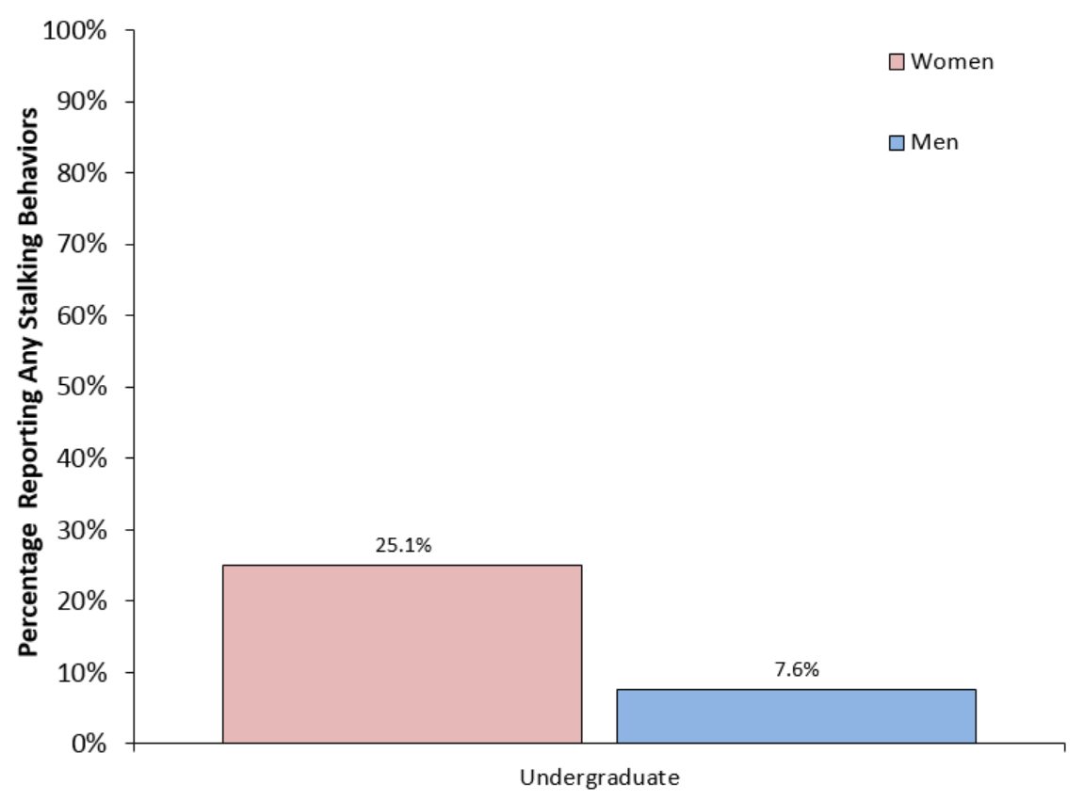

Students were also asked a series of questions related to the context of the incident of stalking behavior that had the greatest effect on them. Data related to this question set are also presented in Table 10.

**Table 10. Percentages of students reporting at least one incident of stalking and context of the incident with the greatest effect on them.**

|  |  |  |  |
| --- | --- | --- | --- |
|  |  | | |
|  | Women | Men | Overall |
| Experienced at least one stalking behavior | 25.1 | 7.6 | 15.1 |
| Perpetrator was a stranger | 21.7 | 23.8 | 21.4 |
| Perpetrator was a PSU student | 76.1 | 76.2 | 75.7 |
| Perpetrator was faculty/staff | 0.0 | 4.8 | 1.4 |
| Perpetrator was a man | 97.8 | 42.9 | 81.4 |
| Location (On campus) | 73.9 | 42.9 | 64.3 |

## Intimate Partner and Dating Violence

Students also responded to a series of questions referencing intimate partner and dating violence (IPV/DV). Questions in this section of the survey asked respondents to think about any hook-up, boyfriend, girlfriend, husband, or wife they have had – including exes, and regardless of length of relationship – since enrolling at Penn State, before indicating whether they had experienced the following specific behaviors:

* The person threatened to hurt me and I thought I might really get hurt.
* The person pushed, grabbed, or shook me.
* The person hit me.
* The person beat me up.
* The person stole or destroyed my property.
* The person can scare me without laying a hand on me.

Figure 2 and table 11 summarize responses to experiencing these behaviors.

**Figure 2. Percentages of students reporting at least one incident of IPV/DV by gender and student level.**

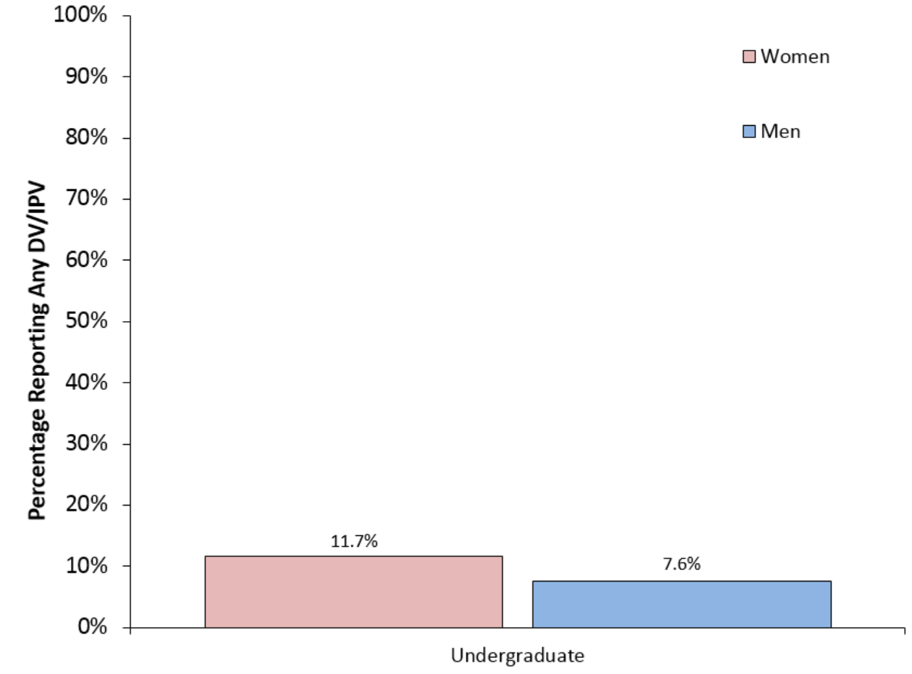

Also included in Table 11, is the context for the IPV/DV incident that had the greatest effect on the respondents.

**Table 11. Percentages of students reporting at least one incident of IPV/DV and context of the incident with the greatest effect on them.**

|  |  |  |  |
| --- | --- | --- | --- |
|  |  | | |
|  | Women | Men | Overall |
| Victim of at least one act of Dating/IPV Violence | 11.7 | 7.6 | 9.3 |
| Perpetrator was a stranger | 0.0 | 0.0 | 0.0 |
| Perpetrator was a PSU student | 56.5 | 45.0 | 52.3 |
| Perpetrator was faculty/staff | 4.4 | 0.0 | 2.3 |
| Perpetrator was a man | 100.0 | 10.0 | 59.1 |
| Location (On campus) | 39.1 | 25.0 | 31.8 |

## Non-consensual Sexual Contact and Sexual Assault Victimization

Students were also asked to report their experiences related to specific forms of non-consensual sexual contact, including:

* Fondling, kissing, or rubbing up against the private areas of the respondent’s body (lips, breast/chest, crotch, or butt), or removing clothes without consent;
* Having oral sex with the respondent or making the respondent perform oral sex without consent;
* Putting the penis, fingers, or other objects into the respondent’s vagina without consent[3];
* Putting the penis, fingers, or other object into the respondent’s butt without consent;
* Attempting (unsuccessfully) to have oral, anal, or vaginal sex without the respondent’s consent.

For each form of non-consensual sexual contact, respondents were asked to report the method by which non-consensual sexual contact was obtained, including:

**Acts of *Coercion***

* Telling lies, threatening to end the relationship, threatening to spread rumors about the respondent, making promises the respondent knew were untrue, or continually verbally pressuring the respondent after they said they did not want to continue;
* Showing displeasure, criticizing the respondent’s sexuality or attractiveness, getting angry but not using physical force after the respondent said they did not want to continue;

***Incapacitation***

* Taking advantage of the respondent when they were too drunk or out of it to know what was happening;

***Force or Threats of Force***

* Threatening to physically harm the respondent or someone close to the respondent;
* Using physical force, for example: holding the respondent down, pinning their arms, or having a weapon.

### Victimization Rates of Any Non-consensual Sexual Contact

Table 12 shows the percentages of students that experience any of the non-consensual sexual contact described above.

**Table 12. Percentages of students reporting any non-consensual touching, penetration, or attempted penetration.**

|  |  |  |  |
| --- | --- | --- | --- |
|  |  | | |
|  | Women | Men | Overall |
| Victim of at least one instance of unwanted touching, penetration, or attempted penetration | 19.0 | 9.9 | 14.0 |

### Victimization Rates of Sexual Assault

Sexual assault is defined here as any of the non-consensual acts that involve completed or attempted sexual penetration. Therefore, these numbers exclude behaviors that involve non-consensual touching/kissing/fondling. Table 13 and Figure 3 summarize the reported victimization data for incidents that meet this definition of sexual assault.

**Table 13. Percentages of students reporting sexual assault involving penetration or attempts at penetration (excludes non-consensual touching/kissing/fondling).**

|  |  |  |  |
| --- | --- | --- | --- |
|  |  | | |
|  | Women | Men | Overall |
| Victim of at least one instance of completed or attempted oral, vaginal, or anal sexual assault | 14.5 | 4.2 | 8.7 |

**Figure 3. Percentages of students reporting at least one incident of sexual assault by gender and student level.**

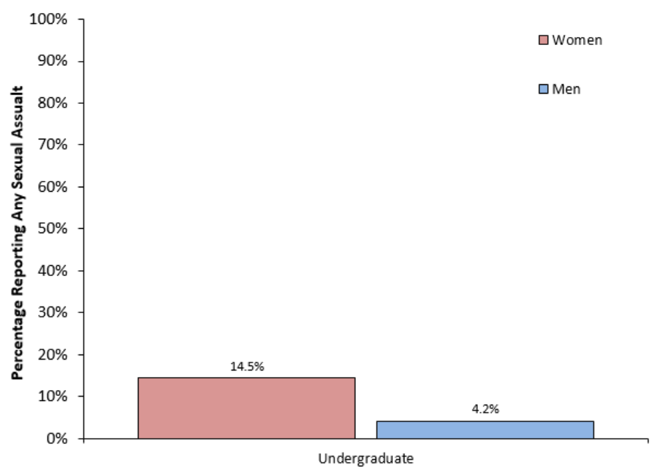

Sexual assault can be further broken down into the tactics used by the perpetrator to commit the offenses without consent including coercion, incapacitation, and force or threats of force as defined above. The rates of each of these tactics is found in table 13a.[4]

**Table 13a. Percentages reporting sexual assault involving penetration or attempts at penetration (excludes non-consensual touching/kissing/fondling) by tactic.**

|  |  |  |  |
| --- | --- | --- | --- |
|  |  | | |
|  | Women | Men | Overall |
| Coercion | 7.8 | 2.3 | 4.9 |
| Incapacitation | 10.6 | 2.3 | 5.6 |
| Force or threats of force | 7.3 | 1.9 | 4.2 |

### Victimization Rates of Non-consensual Sexual Touching, Fondling, or Kissing

Respondents were asked a series of questions regarding their experiences with incidents of non-consensual sexual touching. The category of non-consensual sexual touching excludes acts of sexual assault that involve penetration or attempted penetration. Table 14 and Figure 4 detail response rates related to this question set.

**Table 14. Percentages of students reporting non-consensual touching (excludes assault by penetration or attempted penetration).**

|  |  |  |  |
| --- | --- | --- | --- |
|  |  | | |
|  | Women | Men | Overall |
| Victim of at least one act of non-consensual sexual touching/fondling/kissing | 15.1 | 9.1 | 12.0 |

**Figure 4. Percentages of students reporting at least one incident of non-consensual touching by gender and student level.**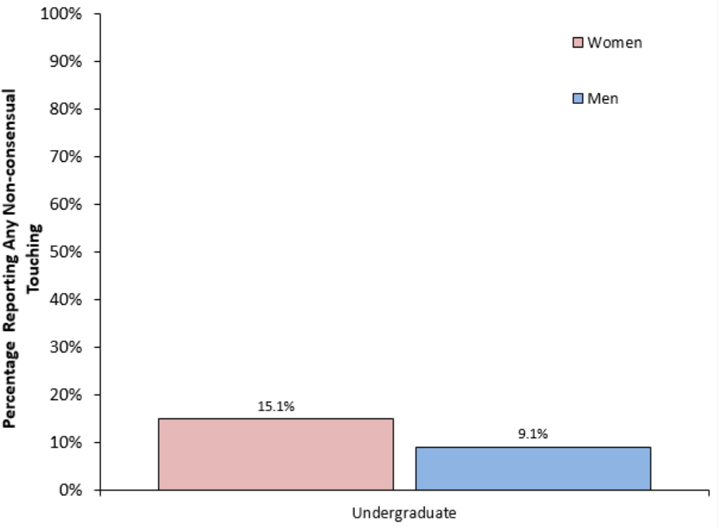

**Table 14a. Percentages of students reporting non-consensual touching (excludes assault by penetration or attempted penetration) by tactic.**

|  |  |  |  |
| --- | --- | --- | --- |
|  |  | | |
|  | Women | Men | Overall |
| Coercion | 9.5 | 4.6 | 7.1 |
| Incapacitation | 10.6 | 5.3 | 7.3 |
| Force or threats of force | 5.6 | 1.9 | 3.6 |

### Context of Any Non-consensual Sexual Contact Victimization

Respondents who reported experiencing at least one incident of non-consensual sexual contact since being enrolled at Penn State were further asked to provide the following information regarding the details of the incident that had the greatest effect on them:

* Whether the perpetrator was a stranger or known to the victim;
* Whether the perpetrator was a Penn State student;
* The gender of the perpetrator;
* Where the incident occurred (on or off campus);
* Whether alcohol or drugs were present or used by any parties involved in the incident.[5]

Table 15 details the responses of students who indicated that they had experienced at least one incident of non-consensual sexual touching.

**Table 15. Percentages of students indicating context of any non-consensual contact victimization.**

|  |  |  |  |
| --- | --- | --- | --- |
|  |  | | |
|  | Women | Men | Overall |
| Perpetrator was a stranger | 17.7 | 23.1 | 19.1 |
| Perpetrator was a PSU student | 55.9 | 38.5 | 50.8 |
| Perpetrator was a faculty/staff | 0.0 | 0.0 | 0.0 |
| Perpetrator was a man | 97.1 | 15.4 | 63.5 |
| Location (on campus) | 38.2 | 15.4 | 30.2 |
| Any presence of drinking or drugs by parties involved | 73.5 | 69.2 | 69.8 |
| Victim: Use of alcohol and/or drugs just prior to the incident | 64.7 | 60.0 | 61.3 |
| Perpetrator: Use of alcohol and/or drugs just prior to the incident | 67.7 | 56.0 | 61.3 |

## Reporting

Students who reported experiencing any type of sexual misconduct anywhere in the survey were asked if they told anybody about the incident or incidents. Of Behrend students who reported any stalking, IPV/DV, or non-consensual sexual contact of any kind, 49.2% of women and 27.9% of men reported telling someone about the incident or incidents. Students indicating they had told someone about the incident were then asked whom they told. Table 16 shows various categories of individuals identified in the survey, along with the percentage of respondents indicating that they told someone in each specific category. Note that percentages in Table 16 are only for those students that reported telling someone about their experience.

**Table 16. Percentages of students who spoke with someone about an incident of stalking, IPV/DV, or non-consensual sexual contact.**

|  |  |  |  |
| --- | --- | --- | --- |
|  |  | | |
|  | Women | Men | Overall |
| Roommate | 28.1 | 53.9 | 35.4 |
| Close friend other than roommate | 71.9 | 76.9 | 73.0 |
| Romantic partner | 46.9 | 30.8 | 41.7 |
| Parent or Guardian | 18.8 | 30.8 | 20.8 |
| Other family member | 6.3 | 30.8 | 12.5 |
| Doctor/nurse | 6.3 | 7.7 | 6.3 |
| Religious leader | 3.1 | 0.0 | 2.1 |
| Off-campus rape crisis center staff | 3.1 | 0.0 | 2.1 |
| Off-campus counselor/therapist | 3.1 | 0.0 | 2.1 |
| On-campus counselor/therapist | 6.3 | 0.0 | 6.3 |
| Institution health services | 3.1 | 0.0 | 2.1 |
| Campus security or police department | 3.1 | 0.0 | 2.1 |
| Local police | 3.1 | 0.0 | 2.1 |
| Office of Student Conduct | 0.0 | 0.0 | 0.0 |
| Resident Advisor or Residence Life staff | 0.0 | 0.0 | 2.1 |
| Institution faculty or staff | 0.0 | 0.0 | 0.0 |

Students who indicated they did not report the incident to Student Conduct, local law enforcement, or University Police were asked what prevented them from reporting to those officials. Table 17 presents the percentages for each reason presented in the survey. (Note that students could check all reasons that apply. Therefore, columns add to greater than 100%.)

**Table 17. Percentages of students indicating reasons why they did not report incidents of stalking, IPV/DV, or non-consensual sexual contact to an authority.**

|  |  |  |  |
| --- | --- | --- | --- |
|  |  | | |
|  | Women | Men | Overall |
| I was too embarrassed. | 29.5 | 14.0 | 22.9 |
| I didn’t think they would believe me. | 8.2 | 14.0 | 11.0 |
| It would cause more trouble than it was worth. | 73.8 | 62.8 | 69.7 |
| I didn’t want to get the person who did it in trouble. | 23.0 | 16.3 | 19.3 |
| I thought I would be punished. | 3.3 | 4.7 | 3.7 |
| I didn’t think the police would take me seriously. | 6.6 | 11.6 | 9.2 |
| People who do these things don’t get brought to justice anyway. | 13.1 | 7.0 | 11.9 |

## Bystander Intervention Behavior

Students were asked a number of questions about how they behaved when they were in situations during which sexual misconduct was occurring or was likely to occur. In addition, they were asked about their motivations for acting as a bystander — and the barriers that can prevent them from acting as a bystander — when in situations during which sexual misconduct was occurring or was likely to occur.

Table 18 shows the percentage of students reporting that they intervened “most of the time” or “always” in situations during which sexual misconduct was occurring or was likely to occur.

**Table 18. Percentages of students reporting that they acted “most of the time” or “always” when a bystander in each situation.**

|  |  |  |  |
| --- | --- | --- | --- |
|  |  | | |
|  | Women | Men | Overall |
| Walked a friend who has had too much to drink home from a party, bar, or other social event. | 28.3 | 27.5 | 29.1 |
| Talked to the friends of a drunken person to make sure they don’t leave him/her behind at a party, bar, or other social event. | 41.1 | 34.6 | 37.7 |
| Spoke up against sexist jokes. | 32.4 | 11.1 | 19.6 |
| Tried to distract someone who was trying to take a drunken person to another room or trying to get them to do something sexual. | 27.3 | 18.4 | 21.7 |
| Ask someone who looks very upset at a party if they are okay or need help. | 43.7 | 31.9 | 36.9 |
| Intervene with a friend who was being physically abusive to another person. | 36.0 | 39.0 | 38.6 |
| Intervene with a friend who was being verbally abusive to another person. | 37.6 | 32.1 | 35.2 |

Students were also asked to select the top three reasons they did not act when they were in a situation in which they felt sexual misconduct might occur or be occurring. Table 19 shows the rates at which students indicated these barriers. (Note that because up to 3 items could be selected, columns add to more than 100%).

**Table 19. Percentages of students indicating barriers as one of the top three reasons for not acting in a situation where sexual misconduct could occur or was occurring.**

|  |  |  |  |
| --- | --- | --- | --- |
|  |  | | |
|  | Women | Men | Overall |
| You didn’t notice the situation at the time because you were also intoxicated. | 38.0 | 46.8 | 43.1 |
| No one else seemed to think it was an issue. | 10.1 | 18.3 | 14.7 |
| You didn’t have enough information to determine if it was concerning enough to intervene. | 61.5 | 64.6 | 63.6 |
| It’s not your place to tell them what to do. | 9.5 | 9.1 | 9.1 |
| You didn’t know how to intervene. | 38.6 | 26.6 | 31.1 |
| You thought you would make the situation worse. | 27.9 | 27.8 | 27.8 |
| You were concerned for your own safety. | 52.5 | 39.2 | 44.9 |
| You didn’t want to embarrass yourself or others. | 7.8 | 7.6 | 7.8 |
| You worried about the long-term social repercussions of intervening. | 5.6 | 6.5 | 6.4 |
| You assumed someone else would intervene. | 7.3 | 11.0 | 9.3 |
| You didn’t know the person well enough. | 21.8 | 20.9 | 21.1 |

## Comparisons to National Data

As mentioned previously, a number of past studies have yielded oft-cited estimates of national victimization rates surrounding issues of sexual misconduct on college campuses (e.g., Koss, Gidycz, & Wisniewski, 1987; and Krebs, Lindquist, Warner, Fisher, & Martin, 2007). Two of the more recent studies were conducted by the AAU and the Bureau of Justice Statistics (BJS).[6] Despite the concerns that led to the decision not to conduct the AAU survey at Penn State, the AAU survey, which collected data from 27 named institutions, does stand as one of the most recent national studies of the climate surrounding sexual misconduct on college campuses. This section will therefore present comparisons to the AAU survey where appropriate. Where valid comparisons between the Penn State and AAU surveys cannot be made, the reasons for the lack of comparison will be noted for the reader. [7] The full AAU report can be found at the following link: <https://www.aau.edu/Climate-Survey.aspx?id=16525>.

### Perceptions of Campus Climate

Four of the items from the Penn State section on students’ perceptions of how the institution would handle a report of sexual misconduct were worded very closely to items on the AAU survey. Table 20 shows the rates at which Behrend students answered “likely” or “very likely” to each item and includes the corresponding AAU rates in parentheses.

**Table 20. Percentages of students reporting the following institutional responses were “likely” or “very likely” to occur if a student reported an incident of sexual misconduct at Penn State, with AAU comparisons in parentheses.**

|  |  |  |  |
| --- | --- | --- | --- |
|  |  | | |
|  | Women | Men | Overall |
| The institution would take the report seriously. | 83.2  (57.1) | 86.7  (70.0) | 85.1  (N/A) |
| The institution would take steps to protect the safety of the person making the report. | 82.1  (51.3) | 88.6  (63.3) | 86.2  (N/A) |
| The institution would take action to address factors that may have led to the sexual misconduct. | 79.3  (36.0) | 82.9  (43.9) | 81.1  (N/A) |
| The institution would handle the report fairly. | 78.8  (45.7) | 79.3  (53.2) | 79.0  (N/A) |

### Offensive Behaviors and Potential Harassment

The Penn State and AAU surveys differ substantially in the ways offensive/harassing behaviors were identified and defined. While neither survey applied a legal or conduct code definition of the term “harassment,” the Penn State survey included a much broader set of behaviors in its question set addressing offensive/harassing behaviors. In addition, the way in which the items were presented differed. For example, the AAU survey first asked respondents whether harassing behaviors were perpetrated by anybody at the university, and then attempted to identify whether the perpetrators were students or faculty/staff. In the Penn State survey, students were asked if faculty/staff committed any of the offensive/harassing behaviors, then separately if students had committed any of those same behaviors. Thus, direct comparisons to the AAU data are not drawn here due to the significant differences between the surveys. The reader is cautioned that any such comparisons may not be meaningful.

### Stalking

The behaviors and the method of asking and determining if any stalking did occur varies too widely from the AAU survey, which was more stringent in identifying if the same person had committed any of the behaviors multiple times. Because of these differences, comparable data from the AAU survey is not presented here.

### Intimate Partner and Dating Violence

Regarding IPV/DV, the AAU survey included questions regarding the use of controlling behaviors, such as not allowing them to see friends or family, in its DV/IPV question set. The AAU definition of IPV/DV was, therefore, broader than that used in the Penn State survey, and — as with harassment and stalking — direct comparisons should be made with caution.

### Non-consensual Sexual Contact

There were also some differences between the Penn State and AAU surveys in question sets addressing non-consensual sexual contact. These differences are not so significant as to prevent meaningful comparisons on this point, however.

18.9% of undergraduate women at Behrend reported experiencing some form of non-consensual sexual contact while enrolled at the University. The range of rates reported in the results of the AAU survey spanned from 17% to 39%.[8]

Further comparisons can be made between the AAU and Penn State surveys for responses regarding incidents of non-consensual sexual contact involving penetration or attempted penetration (sexual assault). Table 21 shows data for Behrend students broken down by gender, with the AAU rates in parentheses.

**Table 21. Rates of students reporting sexual assault compared to average rates from AAU report in parentheses.**

|  |  |  |  |
| --- | --- | --- | --- |
|  |  | | |
|  | Women | Men | Overall |
| Victim of at least one instance of completed or attempted oral, vaginal, or anal sexual assault | 14.2  (28.5) | 3.9  (7.1) | 8.3  (18.3) |

1. Graduate students were also surveyed at Penn State Behrend. However, this population is small and there were too few responses to include a summary of responses from these students.
2. The University’s SHARE website is a portal through which individuals can access information regarding the various resources, support services, and reporting options available in connection with issues of sexual misconduct.
3. This question was asked only to respondents who indicated that their biological sex was female.
4. Note that, because a student could report that multiple tactics were used in any instance of sexual assault, adding the rates pertaining to any individual tactic results in a percentage that is greater than the overall number presented in Table 13.
5. Note that the survey assured students they were not at fault for the incident if they were under the influence of drugs or alcohol.
6. The BJS survey does not map well to the Penn State survey due to significant differences in the way survey questions were worded and the kinds of information collected. Furthermore, the fact that the BJS survey covered only nine unnamed institutions makes it difficult to assess the validity of any comparisons that might otherwise be made between the results reported by that survey and those reflected in this report.
7. The AAU only collected data from institutions’ flagship campuses. While this makes comparisons to Penn State Commonwealth Campuses less valid, the data are presented here for the reader’s information.
8. The AAU survey did not provide an overall average victimization rate for this item.